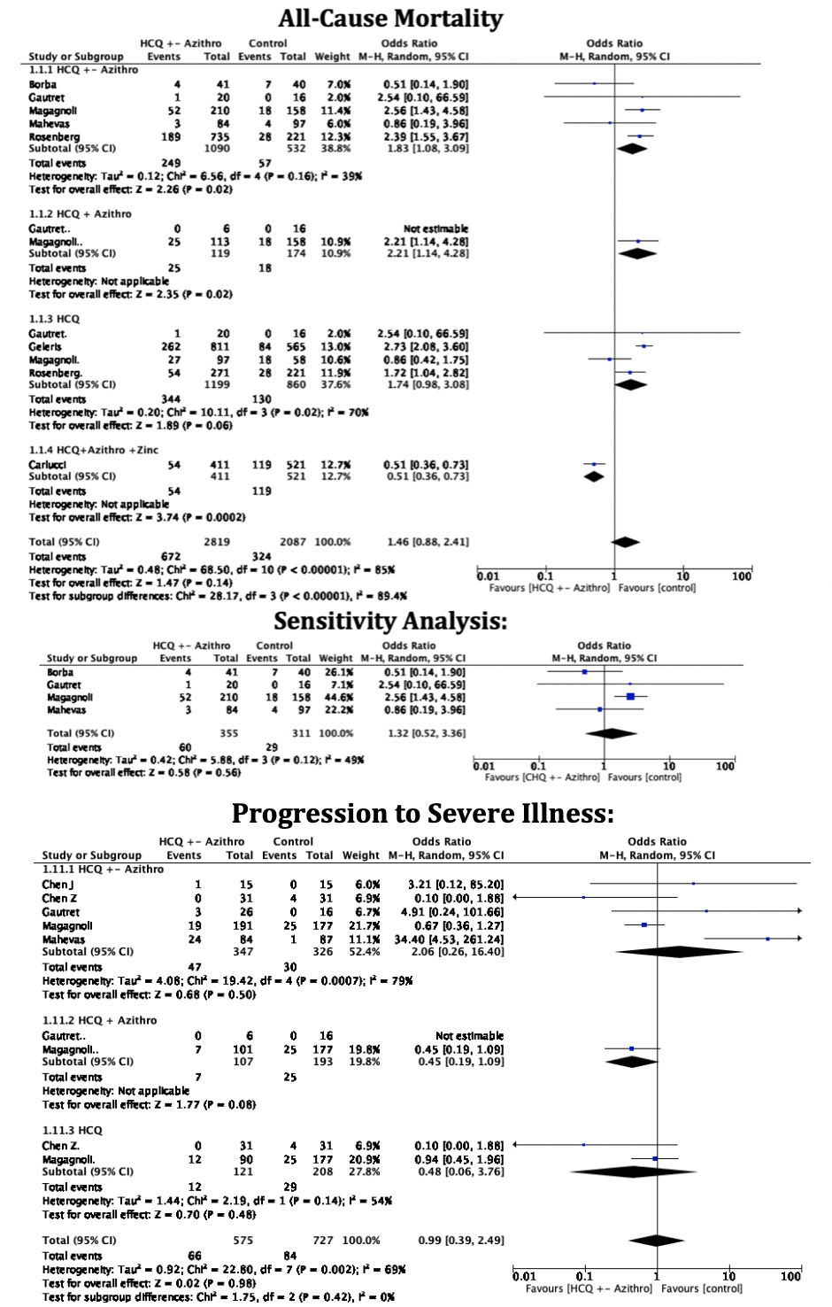
S. Figure 2: Subgroup Forest Plot for a. all-cause mortality, sensitivity analysis of mortality, and progression to severe illness showing an individual and pooled 0R for studies comparing HCQ treated patients with control.

