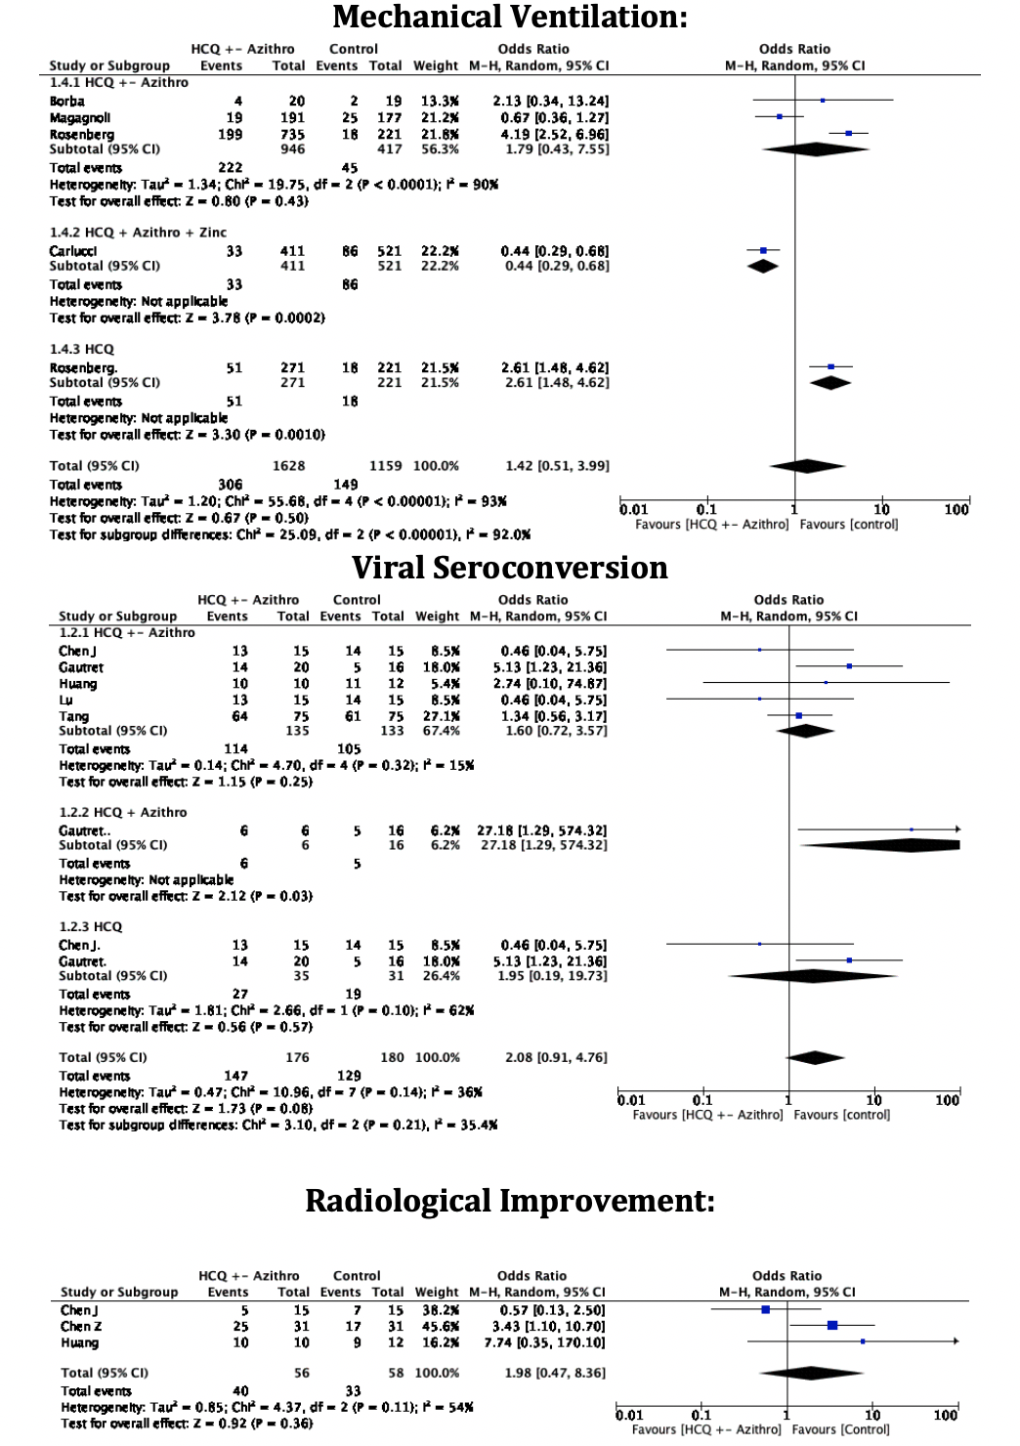
S. Figure 1: Subgroups Forest Plot for a. virologic cure, b. radiological improvement and c. ventilator required showing an individual and pooled 0R for studies comparing HCQ treated patients with control.

